## InfoPath 2010 and Forms Services

**Lab Time**: 75 minutes

**Lab Folder**: C:\Student\Labs\InfoPath

**Lab Overview:** In this lab you will work with InfoPath Forms and Forms Services. You will use InfoPath to create InfoPath form template and publish it to InfoPath form library. Additionally, you will use InfoPath to modify an existing form of a list to provide the end user with a richer experience. Lastly, you will use the InfoPath form Web Part to display your forms from the list.

Lab Setup Requirements

* Before you begin this lab, you must run the batch file named **SetupLab.bat**. This batch file creates a new blank site collection at the location **http://intranet.wingtip.com/sites/workflow**.

### Exercise 1: Creating InfoPath Form Library Forms

In this exercise you will create an InfoPath form template. You will configure that form with logical checks and fetch data from a list to display on the form. Then you will publish the form to the form library in SharePoint.

1. Start InfoPath 2010: **Start » All Programs » Microsoft Office » Microsoft InfoPath Designer 2010**. When InfoPath starts it will show the backstage page that shows all the templates that can be used to start up creating an InfoPath form.
2. Click the **Blank Form** under the **Popular Form Templates** section. In the right task pane, click on the **Design this Form** button.

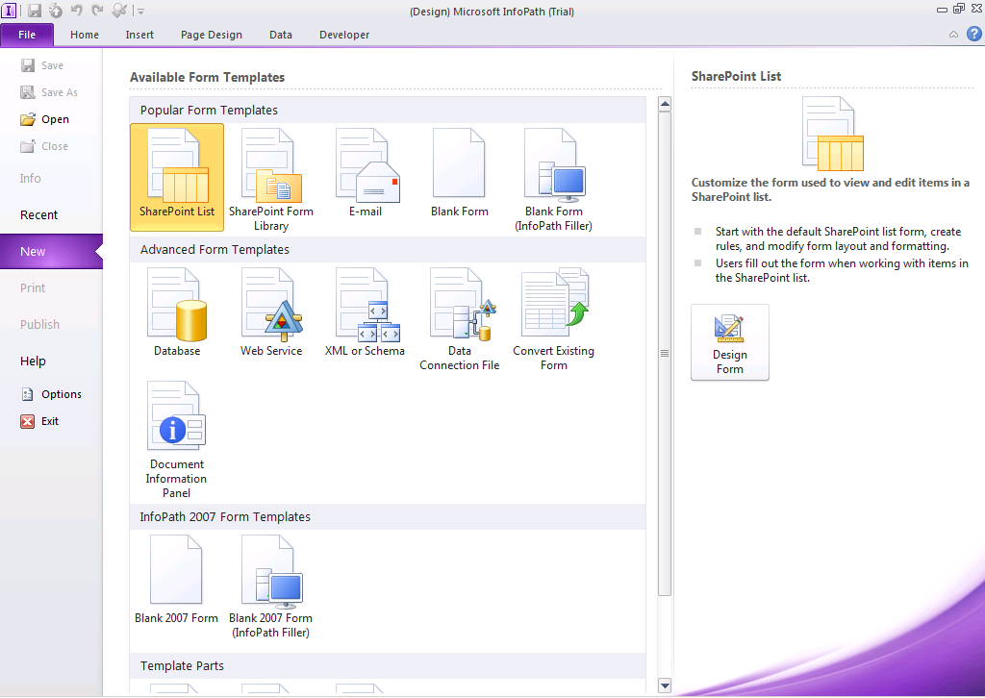

1. The template appears. Where it says **Click to Add Title**, type in **Travel Request Form**.
2. Put the cursor immediately to the left of the **Travel Request Form** label. In the ribbon select **Insert » Picture**. Use the following image in the picture dialog prompt: [[LAB FILES]]\StarterFiles\Wingtip logo.png.
3. Click the image and using the image handlers, resize the image to about half the size of the original image.

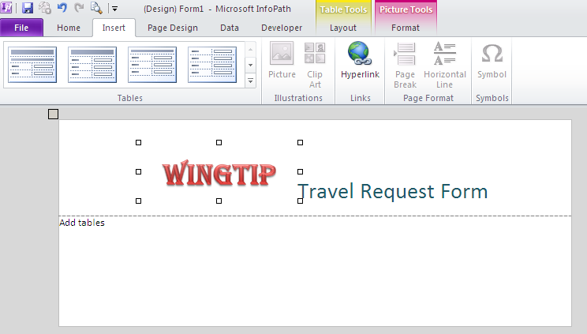

1. Place the cursor in the body of the form where it says **Add Tables**. In the ribbon select **Insert » Custom Tables » 4 column, 3 row** table.
2. Add a row to the table for a heading.
   1. Select any cell in the top row and in the ribbon select from the new **Table Tools** contextual tab group **Layout » Insert Above**.
   2. By default the entire row is selected (if it isn’t, select all cells). Now in the ribbon select **Layout » Merge Cells**.
   3. With the top row still selected, add background shading to the row. Use the **Layout » Shading** selector in the ribbon to pick a color.
   4. Now click the single large cell in the row and enter the text **Employee Information**. Format it to your liking… something like bold, a color that stands out and increasing the font size.
3. In the second row, first column, type **Name:**.
4. Enter other labels in the first and third columns as the following image shows:

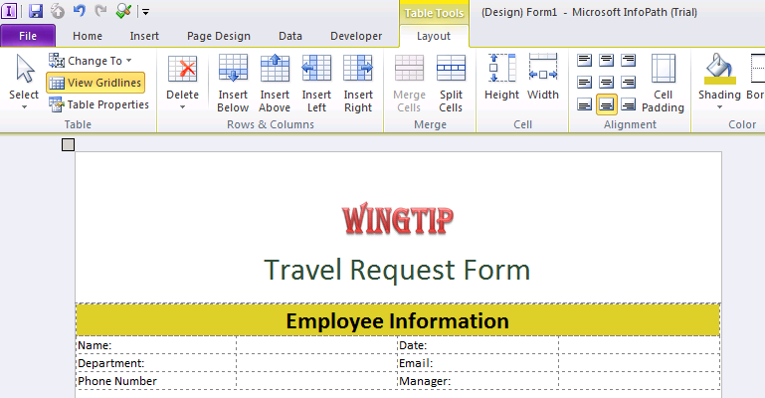

1. Place the cursor outside and just below the current Employee Information table you created and create another table repeating the previous steps and making it look like the following image:

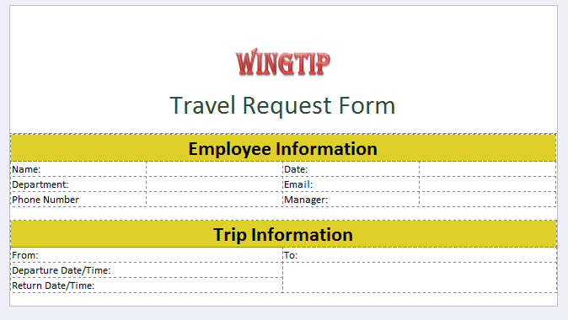

1. You will now insert the controls on the form for the **Employee Information** table.
2. Place the cursor in the first row, second column. Using the ribbon select **Home » [Controls group] » Text Box**. A text box should now appear.
3. When the text box is added to the form, it is automatically selected which triggers the **Control Tools** contextual tab group to be shown. Using the ribbon select **Control Tools » Properties** and use the following information to update the control:

**Name:** EmployeeName

**Cannot Be Blank:** checked

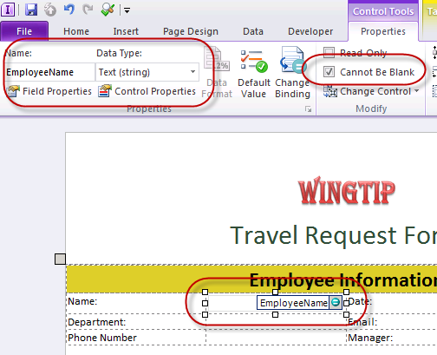

1. In the first row, fourth column, add a **Date Picker** control using the same steps you used to add the text box. Change the field to have the following properties once added:

**Name:** RequestDate

**Cannot Be Blank:** checked

1. Now update the default value for the new **RequestDate** control:
2. With the **RequestDate** control selected, in the ribbon select **Default Value**.
3. In the **Field or Group Properties** dialog box, click the **[fx]** button to the right of the **Value** text box. Then click the **Insert Function** button in the **Insert Formula** dialog.
4. In the **Insert Function** dialog box select the **Date** from the available **Categories** and then select **today**.
5. Click **OK** three times to accept the new default value.

The RequestedDate field will now default to the current date when the form is opened by the end user the first time.

1. Add a new text box control for the Email field and use the following to set the field’s properties:

**Name:** EmailAddress

**Cannot Be Blank:** checked

1. Next, add a validation rule to the **EmailAddress** control to ensure the user entered a valid email address:
2. In the ribbon, with the **EmailAddress** control selected, select **Control Tools » Properties » Add Rule » Is Not an E-mail Address » Show Validation Error**.
3. Set the **ScreenTip** to **Email Address Invalid**.
4. Complete the form for the following labels and controls:
5. **Manager:** **Control**=Person/Group Picker, **Name**=Manager
6. **Phone Number:** **Control**=Text Box, **Name**=PhoneNumber
7. **Department: Control**=Drop Down List Box, **Name=**Department
8. Next, add some validation to the **PhoneNumber** control:
9. With the **PhoneNumber** control selected, use the ribbon to select **Control Tools » Properties » Manage Rules**.
10. Click the **New** button and select **Validation**.
11. Click the **None** link for the **Condition**.
12. In the **Condition** dialog box, select the **PhoneNumber**, **does not match pattern** and then select **Select a pattern…**.
13. In the **Standard Patterns** selector, select **Phone Number** and click **OK** twice to get back to the rule.
14. Set the **ScreenTip** to **Phone Number is not Valid**.
15. Before wiring up the Department control, you need to create a SharePoint list that will contain a few departments.
16. In the browser navigate to **http://intranet.wingtip.com/sites/infopath**.
17. Using the ribbon select **Site Actions » More Options**.
18. Create a new **Custom List** named **Departments**.
19. Add the following departments to the list:

Human Resources

Accounts Payable

Accounts Receivable

Production

IT

1. Go back to **InfoPath 2010**.
2. Next, wire up the Department control to be auto populated with data from an external source:
3. With the **Department** control selected, use the ribbon to select **Control Tools » Properties » Control Properties**.
4. In the **Drop Down List Box Properties** dialog, select the **List box choices** radio button **Get Choices from an external data source**.
5. With no data connections created, click **Add** to create one.
6. Select **Create a new connection to** and select **Receive data**.
7. For the **From where do you want to receive your data?**, select **SharePoint library or list**.
8. Use the SharePoint site location of **http://intranet.wingtip.com/sites/infopath**.
9. Select the **Departments** list.
10. **Check** the first checkbox, **Title** and complete the wizard and **Drop Down List Box Properties** dialog.
11. With the first table complete, move onto the second table. Using the techniques you learned so far in this lab, update the table to look like the following figure. Make sure the controls name the names:

**From:** **Control Type** = Text Box; **Control Name** = TripFrom

**To: Control Type** = Text Box; **Control Name** = TripTo

**Departure Date & Time:** **Control Type** = Date and Time Picker; **Control Name**= DepartureDateTime

**Return Date & Time:** **Control Type** = Date and Time Picker; **Control Name** = ReturnDateTime

1. Add validation rules and default values to the **Trip Information** table’s controls using the techniques you learned building out the previous table:
2. **From**:

**Validation** rule that it **cannot be blank**

1. **To**:

**Validation** rule that it **cannot be blank**

1. **Departure Date and Time**:

**Validation** rule that it **cannot be blank**

1. **Return Date and Time**:

**Validation** rule that it **cannot be blank**

1. Click the Save icon in the ribbon’s Quick Launch menu. Save the template to [[LAB FILES]]\Travel Request Form.xsn.
2. Preview the form to see how it will look when displayed to a user. Using the ribbon select **Home » Preview**. A security warning will appear… you can ignore this and click through it. It is simply warning you that the form is making a remote connection (to the Departments list).

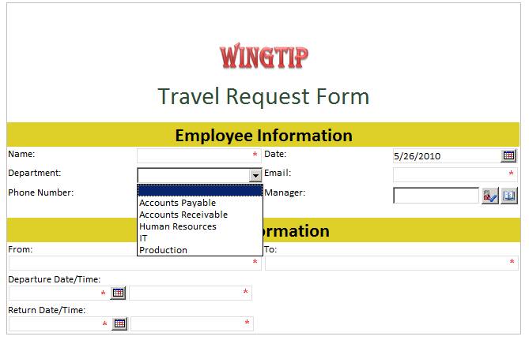

Notice the **Name**, **Phone Number**, **Email**, **From**, **To**, **Departure Date and Time** and **Return Date and Time** fields have an asterisk in front of them indicating they are required fields. The **Date** field should default to today's date. The **Department** drop down should have all the departments coming from the lists in the Human Resources SharePoint site.

After verifying the fields on this form, click on the **Close Preview** button on the ribbon.

1. Publish the form to a new form library in the SharePoint site using the ribbon and backstage page: **File » Publish**.
2. Click the **SharePoint Server** button. The Publishing Wizard should start.
3. In the Publishing Wizard, use the site **http://intranet.wingtip.com/sites/infopath**.
4. Publish the form as a **Form Library**. Set the name of the library to be **Travel Requests**.
5. When prompted to select **The** **fields should be made available as columns in SharePoint sites and Outlook folders** select the following:

**Employee Name**

**Department**

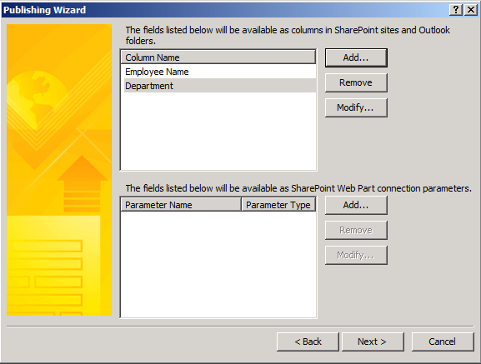

* 1. Click **Next** through the rest of the Publishing Wizard except on the last step, check the box for **Open this form library**.

1. Go back to the browser and navigate to the **http://intranet.wingtip.com/sites/infopath** site.
2. Click the **Travel Requests** library in the Quick Launch.
3. Using the ribbon, fill out a form: **Library Tools » Documents » New Document**.
4. Fill the form out, using the values that you see in the following figure:

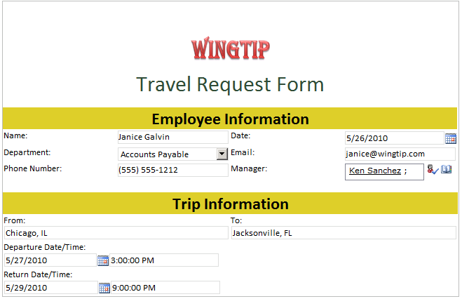

1. In the ribbon, select **Edit » Save**.
2. When prompted, give the form a name and click **Close**.
3. Notice the form is now saved in the library and some of the fields were prompted to be metadata in the list item.

In this exercise you created a new InfoPath form and published it to SharePoint 2010 as a Form Library.

### Exercise 2: Customizing List Forms

In this exercise you will customize the list form of the Tasks list using InfoPath.

1. Open the browser and navigate to **http://intranet.wingtip.com/sites/infopath**.
2. Click the **Tasks** list in Quick Launch.
3. Now use InfoPath to modify the task form:
4. In the ribbon select **List Tools »** **Lists » Customize Form**.
5. InfoPath will load with the default form used for the Task list.

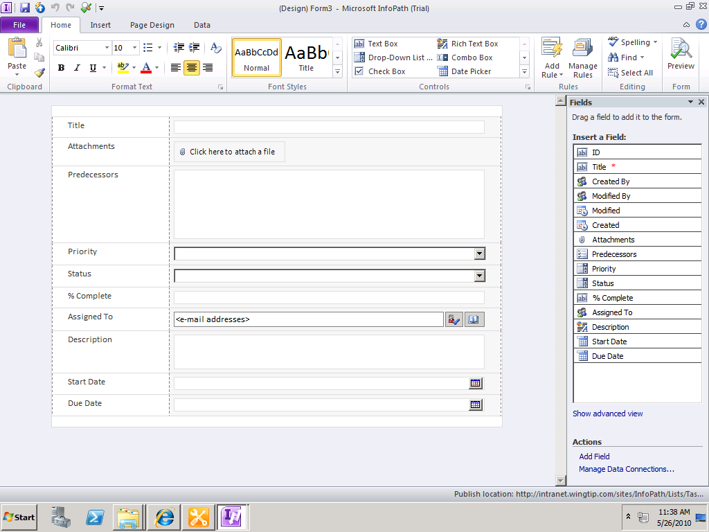

1. Click the top row of this form that is the one above the **Title** field, use the ribbon to **Insert » Picture**.
2. Select the picture [[LAB FILES]]\StarterFiles\Wingtip Logo.png.
3. Resize the logo to be about 50% of the original size.
4. Click the **Title** text box and drag it to the right of the Wingtip logo. It should automatically get inserted at the bottom of the Wingtip logo.
5. Click the **Title** text box control and using the ribbon, change the styling of the control: **Home » Font Size**=18, **Font Weight** = Bold, **Color** = Blue
6. Click either column in the **Title** row in the table. Then use the ribbon to remove the row: **Table Tools » Layout » Delete » Rows**.
7. Resize the **Priority** drop down list box to be about 25% of the original width.
8. Click that cell that contains the Priority drop down list box. Use the ribbon to break it into two cells: **Table Tools » Layout » Split Cells**. Choose the default option of **two columns** and **one row**.
9. In the new column, move the **Status** label and control into this new cell. Resize the **Status** control to be about 25% of the original width.
10. Delete the row that previously contained **Status** by selecting it and selecting **Table Tools » Layout » Delete » Rows**.
11. Resize the **% Complete** text box to about 30% of the original width.

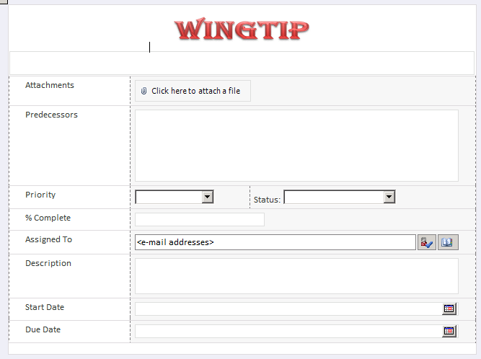

1. Highlight the labels in the first column of the table. Using the ribbon, change their formatting: **Home » Font Weight** = Bold, **Font** = Broadway.
2. Publish the modified form back to the server:
3. Click the **File** tab to bring up the backstage page.
4. Click the **Quick Publish** button. This works because InfoPath already knows where the form came from and that it should be published back to the same location.

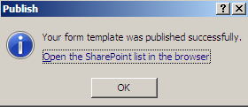

1. Go back to the browser. You should now be looking at the **Tasks** list on the **http://intranet.wingtip.com/sites/infopath** site.
2. Click the **Add new item** link. The new form that you just modified should now appear.

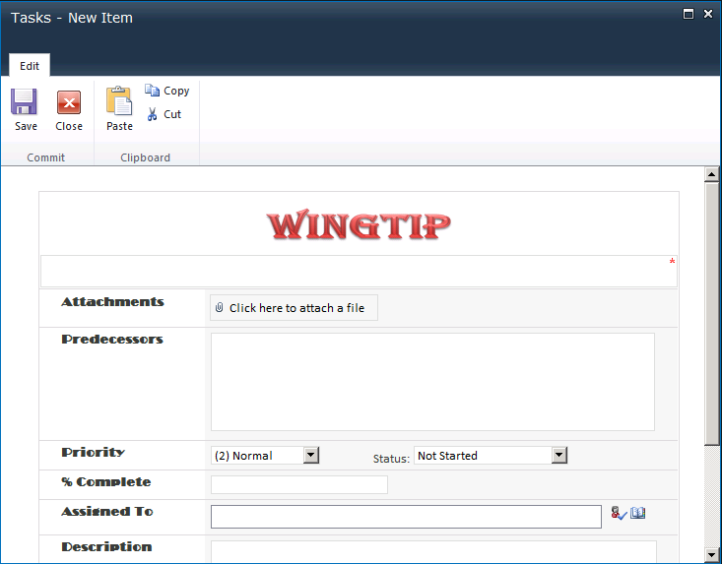

1. Complete the form and click the **Save** button in the ribbon.

In this exercise you used InfoPath 2010 to customizing an existing list form.

### Exercise 3: Displaying Forms using InfoPath Form Web Part

In this exercise you will create a new Web Part Page in which you will show the Task list and also an InfoPath form Web Part, and then you will connect the two together to show the selected task in the InfoPath form Web Part. You will perform this action using SharePoint Designer.

1. Open **SharePoint Designer 2010** and load the **http://intranet.wingtip.com/sites/infopath** site.
2. Click **Site Pages** in the Navigation Pane.
3. Using the ribbon, create a new Web Part Page: **Web Part Page**.
4. Change the Name of the page to Team Tasks.aspx.
5. Click Team Tasks.aspx to view the Summary Page.
6. Click the **Edit File** link in the **Customization** section. The Web Part Page should now appear.

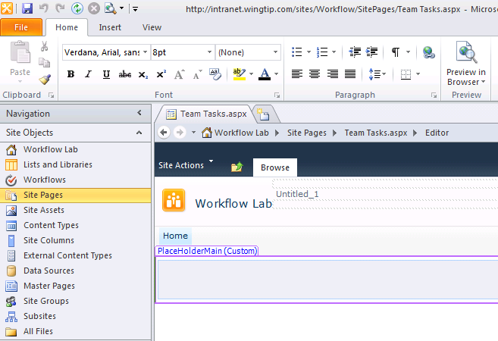

1. Put the cursor in the first Web Part zone on the page. Using the ribbon, add a new Web Part to this zone: **Insert » Data View » Tasks**. The Tasks list should now show up in the top Web Part zone.
2. Place your cursor in the body Web Part Zone which is the one below the header. Using the ribbon add another Web Part: **Insert » Web Part » InfoPath Form Web Part**:

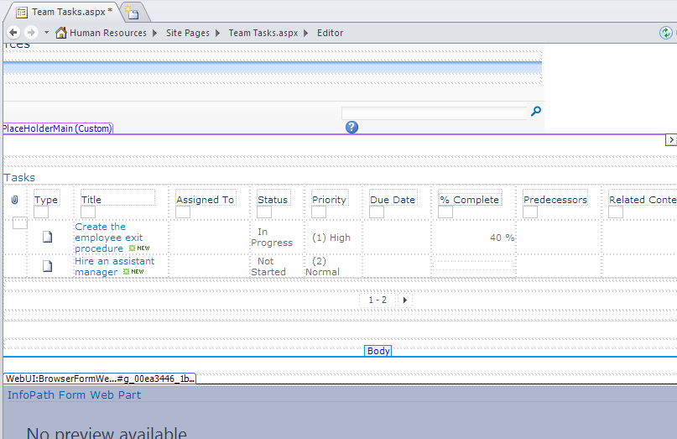

1. With the **InfoPath Form Web Part** selected, use the ribbon to modify the **Web Part:**
2. **Web Part Tools » Format**
3. Click the **Add Connection** button in the ribbon.
4. The Web Part Connections Wizard should appear. Use the drop down to select the option to **Get Form From**.

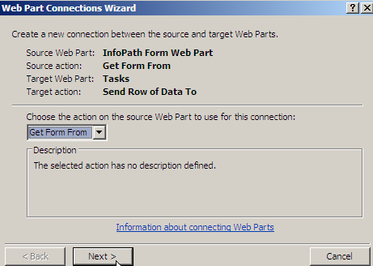

1. Click **Next**, **Next**, **Next**, and **Finish**.
2. **Save** this page.
3. Go back to the browser. Click the **Site Pages** library in the Quick Launch and then the **Team Tasks** page.
4. The Tasks list should show in the first Web Part zone and the InfoPath Form Web Part showing the first task should show in the bottom zone.
5. Click the icon under the **Select column in Tasks list**. The second task should now be showing in the InfoPath form Web Part.

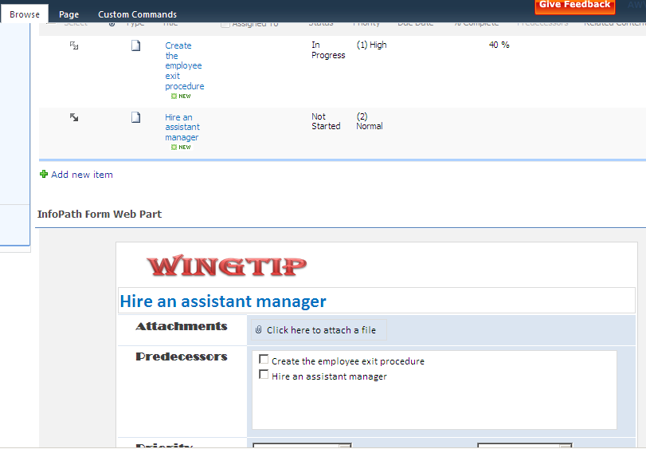

In this exercise you created a new Web Part Page that leveraged the InfoPath Form Web Part.